Practice Questions for the Multiplier Quiz: A selection of these will make up the next Quiz (with different numbers).

- Fred Jones withdraws $1,000 in cash from his savings account. What immediate effect does this transaction have on the monetary aggregate measures of M1 and M2 ?
M1 M2
- Increase Decrease
- Increase no change
- decrease no change
- no change decrease
- no change no change

- What are bank reserves?
- Deposits that are held in the form of gold reserves
- The sum of all loans a bank makes to borrowers
- The value of investments a bank keeps in excess of the value of deposits
- The fraction of deposits kept as currency or on deposit at the Federal Reserve
- The value of owner’s equity in the bank

- If the RRR is 10% and $300 is deposited into a bank, by how much can that bank increase its loans? (Hint: The bank will use any excess reserves to increase the amount of loans because this is available money not being used.)
- $200
- $30
- $300
- $270
- $280

- If the RRR is 10% and $200 is deposited into a bank, by how much can that bank increase its loans? (Hint: The bank will use any excess reserves to increase the amount of loans because this is available money not being used.)
- $200
- $20
- $190
- $220
- $180

- Suppose a bank receives a deposit of $10,000. The RRR is 0.1. By how much did the bank’s excess reserves increase?
- $10,000
- $1000
- $8000
- $11,000
- $9000

- Suppose a bank receives a deposit of $10,000. The RRR is 0.1. By how much did the bank’s required reserves increase?
- $10,000
- $1000
- $8000
- $11,000
- $9000

- If the RRR is 20% and $500 is deposited into a bank, by how much can that bank increase its loans?
- $20
- $100
- $400
- $500
- $480

- If the reserve requirement is 20 percent, then $50 worth of excess reserves in the banking system can lead to a maximum expansion of the money supply equal to
- $20
- $50
- $200
- $250
- $500

- If the required reserve ratio is 10 percent, what is the maximum change in demand deposits possible in the banking system if Denise deposits $25 into her checking account?
- $10
- $25
- $200
- $250
- $400

- Northern City Bank keeps no excess reserves. Assume Northern City Bank receives a deposit of $50 million dollars. As a result of the deposit, Northern City bank’s required reserves increased by $10 million. What is the maximum possible change in the money supply in the banking system that could result from the $50 million deposit?
- The money supply will increase by a maximum of $10 million.
- The money supply will increase by a maximum of $40 million.
- The money supply will increase by a maximum of $50 million.
- The money supply will increase by a maximum of $200 million.
- The money supply will increase by a maximum of $250 million.

- Southern City Bank keeps no excess reserves. Assume Southern City Bank receives a deposit of $50 million dollars. As a result of the deposit, Southern City bank’s required reserves increased by $10 million. What is the maximum possible change in the deposits in the banking system that could result from the $50 million deposit?
- The money supply will increase by a maximum of $10 million.
- The money supply will increase by a maximum of $40 million.
- The money supply will increase by a maximum of $50 million.
- The money supply will increase by a maximum of $200 million.
- The money supply will increase by a maximum of $250 million.

- A bank has a decrease in deposits of $1000. By how much will the total deposits in the banking system decrease as a result of this change if the Required Reserve ratio is 25%?
- $1000
- $4000
- $5000
- $3000

- A bank currently has $50,000 in excess reserves. By what amount can the money supply increase if the RRR = 0.33?
- $150,000
- $50,000
- $15000
- $100,000
- $200,000

- Select all that apply. Which of the following factors correctly explains why the actual increase in money supply from the banking system is often smaller than the maximum increase in money supply?
- It does not take into account the changes in inflation.
- Banks keep excess reserves
- Banks may want to lend out money but there is no demand from borrowers
- Customers hold extra cash and don’t deposit in banks
- It does not take into account the change in foreign exports.

- If the public increases its desire to hold money as currency, what will the effect on the banking system?
- Banks would be more able to control interest rates.
- Banks would be less able to control interest rates.
- Banks would be more able to expand credit.
- Banks would be less able to expand credit.
- Banks would be more able to increase reserves.

- If the reserve requirement is 10 percent but banks voluntarily keep some excess reserves, a $6,000 increase in new reserves will result in
- an increase in the money supply of $6,000
- an increase in the money supply of $60,000
- an increase in the money supply of less than $60,000
- a decrease in the money supply of $60,000
- a decrease in the money supply of more than $60,000

- A bank with no excess reserves receives a $10,000 cash deposit from a new customer. If the required reserve ratio is 20 percent, what is the maximum amount by which the banking system can increase loans.
- $2,000
- $8,000
- $10,000
- $20,000
- $40,000

- Southern City Bank has $100 million in deposits and has $8 million in excess reserves. If the required reserve ratio is 10% which of the following is true?
- The money multiplier is 10 and the bank can lend up to $80 million.
- The money multiplier is 10 and loans can increase in the banking system by a maximum of $80 million.
- The money multiplier is 8 and the bank can lend out up to $20 million.
- The money multiplier is 8 and the bank can lend out up to $5 million.
- The money multiplier is 8 and the loans can increase the banking system by a maximum of $8 million.

- Simon opens a new checking account and deposits $8,000 in cash in JCM Bank. The required reserve ratio is 10 percent.
a) Draw a correctly labeled balance sheet (TT-account) for JCM Bank and show the numerical value of each of the following as a result of this deposit before any loans have been made.
• (i) Change in Required Reserves (RR)
• (ii) Change in Excess Reserves (ER)
• (iii) Change in Demand Deposits (DD)
(b) What is the maximum amount of loans that JCM Bank can initially make from Simon’s deposit? Provide a numerical value.
(c) As a result of Simon’s deposit, calculate the maximum amount by which the money supply will increase throughout the banking system. Show your work.
- Janet Smith deposits $1,000 of her cash holdings in her checking account at First Federal Bank. The reserve requirement is 20 percent and the bank has no excess reserves.
- What is the immediate effect of her deposit on the money supply? Explain why.
- What is the maximum amount of money First Federal can initially loan out? Explain how you determined this amount.
- What is the maximum amount of money the entire banking system can create? Explain how you determined this amount.
- Give one reason why the money supply may not increase by the amount you identified in (c).

1 | E | 11 | E
2 | D | 12 | B
3 | D | 13 | A
4 | E | 14 | 2,3, 4
5 | E | 15 | D
6 | B | 16 | C
7 | C | 17 | E
8 | D | 18 | B
9 | D | 19
10 | D | 20

Answers:
1 | E | 11 | E
2 | D | 12 | B
3 | D | 13 | A
4 | E | 14 | 2,3, 4
5 | E | 15 | D
6 | B | 16 | C
7 | C | 17 | E
8 | D | 18 | B
9 | D | 19
10 | D | 20
19
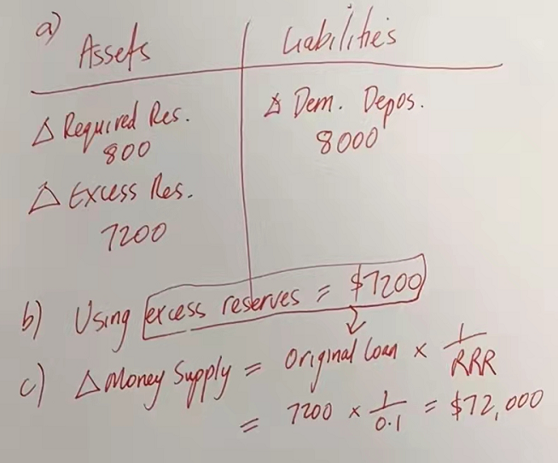
20
a)
• 1 point No immediate change in the money supply
• 1 point Currency falls but demand deposits increase (M= ↓C+ ↑D)
b)
• 1 point $800
• 1 point 1000 – 200 of required reserves = 800 (where 200 = 1000 x 0.20)
c)
• 1 point $4,000
• 1 point $4000 found by: $1000 x 5 and then subtract the $1000 that was already part of the money supply: $5000-1000 = $4000
or $4000 found by multiplying $800 x 5
(where 5 = Money multiplier = 1/ rr = 1/ 0.2)
• Alternate explanation worth 1 point: $5000 found by $1000 x 5
d)
Possible answers:
• the public holding cash and not redepositing funds in banks
• banks are unwilling to loan out all excess reserves (voluntary excess reserves)
• the public is unwilling to demand loans (insufficient loan demand)
Not acceptable:
• A change in reserve requirements (because this would change the maximum amount that can be lent out, but not the ability for the banking system to lend all that money)

